**NAME- ABHIT ANAND**

**ROLL – BTECH/60066/21**

**ASSIGNMENT – 1**

1. Write a Program to check if a given number is Even or Odd. Take the number as input from the user.

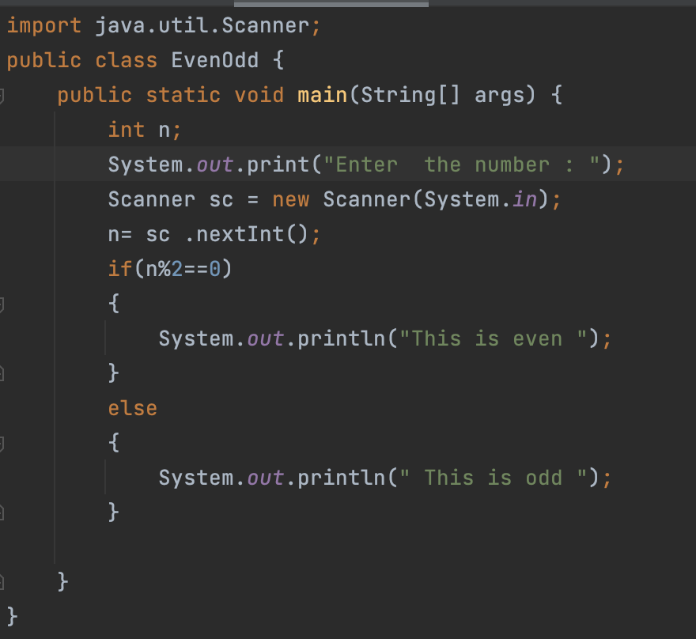

OUTPUT :

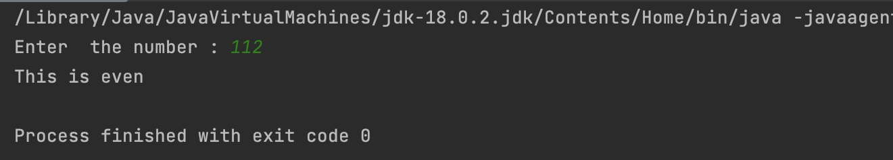

import java.util.Scanner;  
public class EvenOdd {  
 public static void main(String[] args) {  
 int n;  
 Scanner sc = new Scanner(System.*in*);  
 n= sc .nextInt();  
 if(n%2==0)  
 {  
 System.*out*.println("This is even ");  
 }  
 else  
 {  
 System.*out*.println(" This is odd ");  
 }  
  
 }  
}  
2. Write a program to find the largest among 3 numbers taken as input from the user.

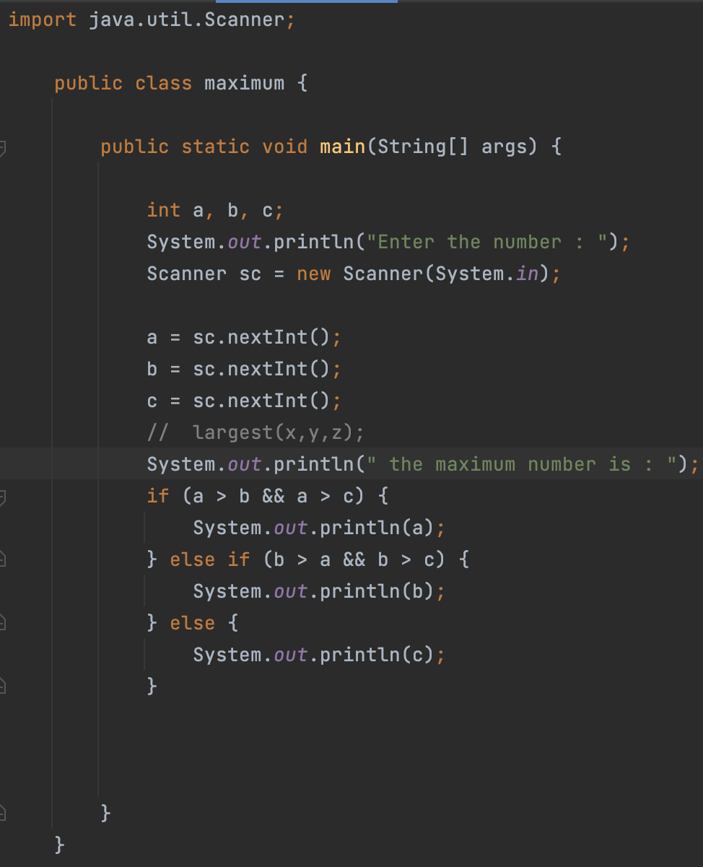

OUTPUT :

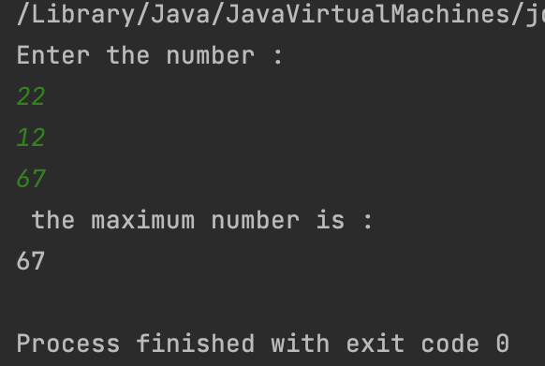

import java.util.Scanner;  
  
public class maximum {  
 static int largest(int a ,int b,int c)  
 {  
 if(a>b && a>c)  
 {  
 System.*out*.println(a);  
 }  
 else if(b>a &&b>c)  
 {  
 System.*out*.println(b);  
 }  
 else  
 {  
 System.*out*.println(c);  
 }  
 return 0;  
 }  
 public static void main(String[] args) {  
  
 int x,y,z;  
 Scanner sc = new Scanner (System.*in*);  
 x=sc.nextInt();  
 y=sc.nextInt();  
 z=sc.nextInt();  
 *largest*(x,y,z);  
  
 }  
}

3. Write a program to Swap two numbers (using temporary variable and without using temporary variable).

import java.util.*;  
public class swap {  
 public static void main(String[] args) {  
 int a,b;  
 Scanner sc =new Scanner (System.*in*);  
 a= sc. nextInt();  
 b= sc. nextInt();  
 a=a+b;  
 b=a-b;  
 a=a-b;  
 System.*out*.print( a);  
 System.*out*.print(b);  
  
 }  
}

4. Write a program to take an integer ‘n’ as an input from the user. Print the factorial from 1 to n.

import java.util.Scanner;  
public class factorial {  
 public static void main(String[] args) {  
 int n,fact=1;  
 Scanner sc = new Scanner(System.*in*);  
 n= sc .nextInt();  
 for (int i=1;i<=n;i++)  
 {  
 fact=fact*i;  
 }  
 System.*out*.println(fact);  
  
 }  
}

**ASSIGNMENT - 1A**

* Write a program to print the PASCALS’s Triangle of n rows taking n as input from the user.

import java.util.Scanner;  
public class pascaltriangle {  
 public static void main(String[] args)  
 {  
 int row,c=1;  
 System.*out*.print("Input number of rows: ");  
 Scanner in = new Scanner(System.*in*);  
 row = in.nextInt();  
 for(int i=0;i<row;i++)  
 {  
 for(int j=1;j<=row-i;j++)  
 System.*out*.print(" ");  
 for(int k=0;k<=i;k++)  
 {  
 if (k==0||i==0)  
 c=1;  
 else  
 c=c*(i-k+1)/k;  
 System.*out*.print(" "+c);  
 }  
 System.*out*.print("\n");  
 }  
 }  
}

* Write a program to find the roots of a quadratic equation. Take the coefficients as input from the user.

import java.util.Scanner;  
public class quadratic {  
 public static void main(String[] args) {  
  
 int a, b,c,discriminant;  
 double root1 ,root2;  
 Scanner sc =new Scanner (System.*in*);  
 a=sc.nextInt();  
 b=sc.nextInt();  
 c=sc.nextInt();  
 discriminant = b*b-4*a*c;  
 if(discriminant >0)  
 {  
 root1 = ((-b) + Math.*sqrt*(discriminant))/(2*a);  
 root2 = ((-b) - Math.*sqrt*(discriminant))/(2*a);  
  
 System.*out*.println(root1);  
 System.*out*.println(root2);  
 }  
 else if(discriminant ==0)  
 {  
 root1=root2 = (-b)/(2*a);  
 System.*out*.println(root1);  
 System.*out*.println(root2);  
 }  
  
 else {  
  
 double realpart = (-b)/(2*a);  
 int imaginarypart =(int)Math.*sqrt*(-discriminant)/(2*a);  
 System.*out*.println(realpart);  
 System.*out*.println(imaginarypart);  
 }  
 }  
}

* Write a program to sort an array of integers and then search for a particular key taken as input from the user.
* Write a program to print the largest and smallest among N numbers taken as input from the user.

import java.util.Scanner;  
public class largest {  
 public static void main(String[] args) {  
// int [] arr;  
 int arr[] =new int[7];  
 System.*out*.println("Enter the number :");  
 for (int i=0;i<7;i++)  
 {  
 Scanner sc=new Scanner(System.*in*);  
 arr[i] =sc.nextInt();  
 }  
  
 int largest =arr[0];  
 int smallest=arr[0];  
 for (int i=0;i<arr.length;i++)  
 {  
 if(arr[i]>=largest) {  
 largest = arr[i];  
 }  
 else if(arr[i]<smallest)  
 {  
 smallest = arr[i];  
 }  
 }  
 System.*out*.println("The largest is :" + largest);  
 System.*out*.println("The smallest is :" + smallest);  
 }  
}  
   
 **ASSIGNMENT – 2**

1. Write a program to check whether a number given as input from the user is a Palindrome or not.

import java.util.Scanner;  
public class palindrome {  
 static void reverse(int a){  
 int b , sum=0,temp;  
 temp=a;  
 while (a>0) {  
  
 b = a % 10;  
 sum = sum * 10 + b;  
 a = a / 10;  
  
 }  
  
 if (sum==temp)  
 {  
 System.*out*.println(" This is palindrome");  
 }  
 else  
 {  
 System.*out*.println("this is not palindrome ");  
 }  
 }  
  
 public static void main(String[] args) {  
 int x;  
 System.*out*.print(" Enter the number to check :");  
 Scanner sc = new Scanner (System.*in*);  
 x= sc.nextInt();  
 *reverse*( x);  
 }  
}

* Write a program to find the largest 2 numbers and the smallest 2 numbers in the array initialized by the user.

public class largestx{  
  
 public static void main(String[]args){  
  
 int[]arr={5,3,9,10,7,2,11,1};  
  
 int min1=arr[0];  
 int min2=0;  
  
 int max1=arr[0];  
 int max2=0;  
  
 for(int i=1;i<arr.length;i++){  
 if(arr[i]>max1){  
 max2=max1;  
 max1=arr[i];  
 }else if(arr[i]<min1){  
 min2=min1;  
 min1=arr[i];  
 }  
 }  
  
 System.*out*.println("Max1 = "+max1+" Max2 = "+max2);  
 System.*out*.println("Min1 = "+min1+" Min2 = "+min2);  
  
 }}

* Write a program to add all the values in a given number and check if the sum is prime number or not.

import java.util.Scanner;  
  
public class sum {  
 public static void main(String[] args) {  
 int m,sum = 0;  
 System.*out*.println("Enter the number ");  
 Scanner sc = new Scanner(System.*in*);  
 int n = sc.nextInt();  
  
 while (n>0) {  
  
  
 m = n % 10;  
 sum = sum + m;  
 n = n / 10;  
  
 }  
 System.*out*.println(sum);  
 int j;  
 for (j = 2; j < sum; j++) {  
 if(sum % j ==0)  
 {  
 System.*out*.println("This is not a prime number ");  
 break;  
 }  
  
 }  
 if (j == sum) {  
 System.*out*.println(" This is a prime number ");  
 }  
 }  
}

* Write a program to print the element of an array that has occurred the highest number of times
* Write a program to take input of 10 students marks in an array. Find out the mean of the marks and print the marks which are greater than the mean.

import java.util.*;  
public class Mean {  
 public static void main(String[] args) {  
 Scanner sc= new Scanner (System.*in*);  
 int [] arr =new int [10];  
 int i,sum=0;  
 System.*out*.println("ENTER THE 1O MARKS ");  
 for ( i=0;i<10;i++)  
 {  
 arr[i] = sc.nextInt();  
 sum=sum+arr[i];  
   
 }  
 float Mean = sum/arr.length;  
 System.*out*.println("mean is "+Mean);  
 System.*out*.println(" List above mean ");  
 for (i=0;i<10;i++)  
 {  
 if (arr[i]>Mean)  
 {  
 System.*out*.println(arr[i]);  
 }  
 }  
 }  
}

ASSIGNMENT 3

1. Write a program in Java with class Rectangle with the data fields width, length, area and color. The length, width and area are of double type and color is of string type. The methods are set_length() , set_width() , set_color(), and find_area(). Create two object of Rectangle and compare their area and color. If area and color same for the objects then display “Matching Rectangles” otherwise display “Non Matching Rectangle”.

import java.io.*;

import java.util.*;

class Rect

{

double width,length,area;

String color;

Scanner sc=new Scanner(System.in);

Rect()

{

System.out.print("Enter the length: ");

length=sc.nextDouble();

System.out.print("Enter the width: ");

width=sc.nextDouble();

System.out.print("Enter the color: ");

color=sc.next();

area=length*width;

System.out.println("Area of Rectangle: "+area);

}

}

class Main

{

public static void main(String arg[])

{

System.out.println("First Rectangle: ");

Rect r1=new Rect();

System.out.println("Second Rectangle: ");

Rect r2=new Rect();

if(r1.area==r2.area && r1.color.equals(r2.color))

System.out.println("Matching Rectangle ");

else

System.out.println("Non Matching Rectangle ");

}

}

1. Write an application that inputs one number consisting of five digits from the user separates the number into its individual digits and prints the digits separated from one another by three spaces each. For example if the user types in the number 42339, the program should print.
2. Create a class called Employee that includes three pieces of information as instance variables-a first name (type String), a last name (type String) and a monthly salary (double). The class should have a constructor that initializes the three instance variables. Provide a set and a get method for each instance variable. If the monthly salary is not positive, set it to 0.0. Write a test application named EmployeeTest that demonstrates class Employee’s capabilities. Create two Employee objects and display each object’s yearly salary. Then give each Employee a 10% raise and display each Employee’s yearly salary again.

class Employee

{

private String firstName;

private String lastName;

private double monthlySalary;

public Employee (String fname, String lname, double msalary) {

firstName = fname;

lastName = lname;

monthlySalary = msalary;

}

public void setFirstName (String fname)

{

firstName = fname;

}

public String getFirstName ()

{

return firstName;

}

public void setLastName (String lname)

{

lastName = lname;

}

public String getLastName ()

{

return lastName;

}

public void setMonthlySalary (double msalary)

{

monthlySalary = msalary;

}

public double getMonthlySalary ()

{

return monthlySalary;

}

public double getYearlySalary()

{

double yearlySalary = monthlySalary * 12;

return yearlySalary;

}

public double getRaiseSalary()

{

double raise = monthlySalary * 0.1 ;

double raiseSalary = ( monthlySalary + raise ) * 12;

return raiseSalary;

}

}

class Sample {

public static void main(String[] args) {

Employee E1 = new Employee("Raj ", "Kumar", 1000);

Employee E2 = new Employee("Om", "kumar", 2000);

System.out.println("The yearly salary of E1 and E2 are" + E1.getYearlySalary() + " and " + E2.getYearlySalary() + " respectively");

System.out.println("the raised yearly salary ofE1 and E2 are" + E1.getRaiseSalary() + " and " + E2.getRaiseSalary() + " respectively");

}

}

**ASSIGNMENT 4**

1. **Create a class box that uses a parameterized constructor to initialize the dimensions of a box (width, height, depth of type double).The class should have a method that calculates and returns the volume of the Box. Obtain an object and print the corresponding volume in main function**.

public class Box {

private double width;

private double height;

private double depth;

Box(int width, int height, int depth){

this.width = width;

this.height = height;

this.depth = depth;

}

double Volume() {

return width * height * depth;

}

public static void main(String[] args) {

// TODO Auto-generated method stub

Box box = new Box(100, 200, 300);

System.out.print("The volume of Box is " + box.Volume()); }

}

1. **Write a program to reverse the elements of a given 2 x 2 array. Four integers need to be passed as Command Line arguments.**

public class Array R{

    public static void main(String args[])  
    {  
    int a=args.length;  
    int x,y,w,z,i;  
    int arr[][] = new int[4][4];  
    if(a<4)  
    {  
    System.out.println("enter 4 values");  
    }  
    if(a==4)  
          
    {  
        int k=0;  
    for(i=0;i<2;i++)  
    {  
        for(int j=0;j<2;j++)  
        {  
              
        arr[i][j]=Integer.parseInt(args[k]);  
        k++;  
        }  
          
    }  
    System.out.println("given array is:");  
    for(i=0;i<2;i++)  
    {  
        for(int j=0;j<2;j++)  
        {  
        System.out.print(arr[i][j]+" ");  
        }  
        System.out.println();  
          
    }  
    System.out.println(" reverse of array is:");  
    for(i=1;i>=0;i--)  
    {  
        for(int j=1;j>=0;j--)  
        {  
        System.out.print(arr[i][j]+" ");  
        }  
        System.out.println();  
          
    }

      
    }    
}  
}

1. **Write a program to convert a Binary number taken as input from the user to its equivalent Decimal, Octal and Hexadecimal format.**
2. **Write a program to find if the three sides given as input from the user can be assigned as 3 sides of a Triangle**.

import java.util.*;

public class Solution {

public static void main(String[] args) {

Scanner in = new Scanner(System.in);

System.out.print("Input side1: ");

int s1 = in .nextInt();

System.out.print("Input side2: ");

int s2 = in .nextInt();

System.out.print("Input side3: ");

int s3 = in .nextInt();

System.out.print("Is the said sides form a triangle: " + Triangle(s1, s2, s3));

}

public static boolean Triangle(int a, int b, int c) {

return (a + b > c && b + c > a && c + a > b);

}

}

ASSIGNMENT 5

1. Create a class named ‘Animal’ which includes methods like eat() and sleep(). Create a child class of Animal named ‘Bird’ and override the parent class methods. Add a new method named fly(). Create an instance of Animal class and invoke the eat and sleep methods using this object .Create an instance of Bird class and invoke the eat, sleep and fly methods using this object.

class Animal {

void eat() {

System.out.println("Animal is eating");

}

void sleep() {

System.out.println("Animal is sleeping");

}

}

class Bird extends Animal {

void eat() {

System.out.println("Bird is eating");

}

void sleep() {

System.out.println("Bird is sleeping");

}

void fly() {

System.out.println("Bird is flying");

}

}

public class Solution {

public static void main(String[] args) {

Animal animal = new Animal();

animal.eat();

animal.sleep();

Bird bird = new Bird();

bird.eat();

bird.sleep();

bird.fly();

}

}

1. A HighSchool application has two classes: the Person superclass and the Student subclass. Using inheritance, in this lab you will create two new classes, Teacher and CollegeStudent. A Teacher will be like Person but will have additional properties such as salary (the amount the teacher earns) and subject (e.g. “Computer Science”, “Chemistry”, “English”, “Other”). The CollegeStudent class will extend the Student class by adding a year (current level in college) and major (e.g. “Electrical Engineering”, “Communications”, “Undeclared”) :

3. Create a base class Fruit which has name ,taste and size as its attributes. A method called eat() is created which describes the name of the fruit and its taste. Inherit the same in 2 other class Apple and Orange and override the eat() method to represent each fruit taste :

class Fruit {

String name, taste, size;

void eat() {

System.out.println("Eating Fruits...");

}

class Apple extends Fruit {

Apple() {

name = "Apple";

taste = "sweet";

size = “Circle”;

}

void eat() {

System.out.println(name + " is "+ taste + " in taste and “+ size + “in shape.”);

}

}

class Orange extends Fruit {

Orange() {

name = "Orange";

taste = "sweet-tert";

}

void eat() {

System.out.println(name + " is "+ taste + " in taste.");

}

}

class Main {

public static void main(String[] args){

Fruit fruit = new Fruit();

Apple apple = new Apple();

Orange orange = new Orange();

fruit.eat();

apple.eat();

orange.eat();

}

}

**ASSIGNMENT 6**

1. Create a class called **Student** that includes three pieces of information as instance variables-a name (type String), a roll_number (type String) and a Semester GPA (double). Use constructor to initialize the instance variables. Provide a method that calculates CGPA, that is average GPA of 4 semesters. Write a test application named **StudentTest** that demonstrates class Student’s capabilities. Create two Student objects and display each object’s name, roll number and CGPA. Data must be taken as user input.

import java.sql.SQLOutput;  
import java.util.Scanner;  
class Student{  
 String name, roll_number;  
 double GPA1, GPA2, GPA3,GPA4;  
 Scanner sc= new Scanner(System.*in*);  
 Student(String N, String R){  
 this.name= N;  
 this.roll_number= R;  
 }  
  
 public String getName() {  
 return this.name;  
 }  
  
 public String getRoll_number() {  
 return this.roll_number;  
 }  
 void setCGPA(){  
 System.*out*.println("Enter all four GPAs");  
 GPA1= sc.nextDouble();  
 GPA2= sc.nextDouble();  
 GPA3= sc.nextDouble();  
 GPA4= sc.nextDouble();  
 }  
 double getCGPA(){  
 return (GPA1+GPA2+GPA3+GPA4)/4;  
 }  
}  
class Solution{  
 public static void main(String[] args) {  
 String nam,rol;  
 Scanner in = new Scanner(System.*in*);  
 System.*out*.println("Enter the name of 1st Student");  
 nam = in.next();  
 System.*out*.println( "Entel roll no.");  
 rol = in.next();  
 Student S1 = new Student(nam,rol);  
 System.*out*.println("The name of student is "+S1.getName()+ " and roll no. is "+S1.getRoll_number());  
 S1.setCGPA();  
 System.*out*.println("The CGPA of " +S1.getName()+ " is " +S1.getCGPA());  
 String nam1 , rol1;  
 System.*out*.println("Enter the name of 2nd Student");  
 nam1 = in.next();  
 System.*out*.println( "Entel roll no.");  
 rol1 = in.next();  
 Student S2 = new Student(nam1, rol1);  
 System.*out*.println("The name of student is "+S2.getName()+ " and roll no. is "+S2.getRoll_number());  
 S2.setCGPA();  
 System.*out*.println("The CGPA of " +S2.getName()+ " is " +S2.getCGPA());  
  
  
 }  
  
}

1. (Rectangle class) Create a class Rectangle. This class has attributes length and width, each of which defaults to 1. It has methods that calculate the perimeter and the area of the rectangle. It has set and get methods for both length and width. The set methods should verify that length and width are each floating-point numbers larger than 0.0 and less than 20.0. Write a program to test class Rectangle.

class ARec  
{  
 float length, width;  
  
 public ARec()  
 {  
 length = 1;  
 width = 1;  
 }  
  
 public float calcPerimeter()  
 {  
 return (length+width)*2;  
 }  
  
  
 public float calcArea()  
 {  
 return length*width;  
 }  
  
 public void setValues(float length,float width)  
 {  
 if (length > 0 && length < 20)  
 this.length = length;  
 if (width > 0 && width < 20)  
 this.width = width;  
 }  
  
 public float doLength()  
 {  
 return length;  
 }  
  
 public float doWidth()  
 {  
 return width;  
 }  
  
  
}  
class RecSquare{  
 public static void main(String[] args) {  
 ARec S1 = new ARec();  
 S1.setValues(15,15);  
 System.*out*.println("Area="+S1.calcArea());  
 System.*out*.println("Perimeter="+S1.calcPerimeter());  
  
 }  
}

1. Write an inheritance hierarchy for classes Quadrilateral, Trapezoid, Parallelogram, Rectangle and Square. Use Quadrilateral as the super class of the hierarchy. Make the hierarchy as deep (i.e., many levels) as possible. Specify the instance variables and methods for each class. The private instance variables of Quadrilateral should be the x-y coordinate pairs for the four end-points of the Quadrilateral. Write a program that instantiates objects of your classes and outputs each object’s area (except Quadrilateral).

class Quad{  
 int x1,x2,x3,x4,y1,y2,y3,y4,height;  
 void setCoordinate(int a,int b,int c,int d,int e,int f,int g,int h){  
 x1=a;y1=b;x2=c;y2=d;x3=e;y3=f;x4=g;y4=h;  
 }  
}  
class Square extends Quad{  
 Square(int a,int b,int c,int d,int e,int f,int g,int h){  
 setCoordinate(a,b,c,d,e,f,g,h);  
 }  
 int area(){  
 int d=(int)Math.*sqrt*((x1-x2)*(x1-x2)+(y1-y2)*(y1-y2));  
 return d*d;  
 }  
}  
  
class rect extends Quad{  
 rect(int a,int b,int c,int d,int e,int f,int g,int h){  
 setCoordinate(a,b,c,d,e,f,g,h);  
 }  
 int area(){  
 int d1=(int)Math.*sqrt*((x1-x2)*(x1-x2)+(y1-y2)*(y1-y2));  
 int d2=(int)Math.*sqrt*((x1-x4)*(x1-x4)+(y1-y4)*(y1-y4));  
 return d1*d2;  
 }  
}  
  
class trapezoid extends Quad{  
 trapezoid(int a,int b,int c,int d,int e,int f,int g,int h,int height){  
 setCoordinate(a,b,c,d,e,f,g,h);  
 this.height=height;  
 }  
 int area(){  
 int d1=(int)Math.*sqrt*((x1-x2)*(x1-x2)+(y1-y2)*(y1-y2));  
 int d2=(int)Math.*sqrt*((x3-x4)*(x3-x4)+(y3-y4)*(y3-y4));  
 return (int)((d1*d2)*height)/2;  
 }  
}  
  
class parallel extends Quad{  
 parallel(int a,int b,int c,int d,int e,int f,int g,int h,int height){  
 setCoordinate(a,b,c,d,e,f,g,h);  
 this.height=height;  
 }  
 int area(){  
 int d1=(int)Math.*sqrt*((x1-x2)*(x1-x2)+(y1-y2)*(y1-y2));  
 return d1*height;  
 }  
}  
  
class TestQuad {  
 public static void main(String[] args) {  
 Square sq = new Square(10, 10, 20, 10, 20, 20, 10, 20);  
 System.*out*.println("Area of Square:" + sq.area());  
  
 rect rec = new rect(10, 10, 30, 10, 30, 20, 10, 20);  
 System.*out*.println("Area of Rectangle:" + rec.area());  
  
 parallel p = new parallel(10, 10, 30, 10, 20, 20, 0, 20, 8);  
 System.*out*.println("Area of Parallelogram:" + p.area());  
  
 trapezoid t = new trapezoid(10, 10, 30, 10, 40, 20, 0, 20, 8);  
 System.*out*.println("Area of Trapezium:" + t.area());  
 }  
}